Install Google chrome on a windows system

sudo apt update

sudo apt -y install wget

wget <https://dl.google.com/linux/direct/google-chrome-stable_current_amd64.deb>

sudo apt install ./google-chrome-stable_current_amd64.deb

accept Installation request

Reading package lists... Done

Building dependency tree

Reading state information... Done

Note, selecting 'google-chrome-stable' instead of './google-chrome-stable_current_amd64.deb'

The following additional packages will be installed:

libappindicator3-1

The following NEW packages will be installed:

google-chrome-stable libappindicator3-1

0 upgraded, 2 newly installed, 0 to remove and 54 not upgraded.

Need to get 53.5 kB/62.2 MB of archives.

After this operation, 221 MB of additional disk space will be used.

Do you want to continue? [Y/n] y

Get:1 /home/jkmutai/google-chrome-stable_current_amd64.deb google-chrome-stable amd64 79.0.3945.130-1 [62.2 MB]

Get:2 <http://kali.download/kali> kali-rolling/main amd64 libappindicator3-1 amd64 0.4.92-7 [53.5 kB]

Fetched 53.5 kB in 12s (4,572 B/s)

Selecting previously unselected package libappindicator3-1:amd64.

(Reading database ... 258571 files and directories currently installed.)

Preparing to unpack .../libappindicator3-1_0.4.92-7_amd64.deb ...

Unpacking libappindicator3-1:amd64 (0.4.92-7) ...

Selecting previously unselected package google-chrome-stable.

Preparing to unpack .../google-chrome-stable_current_amd64.deb ...

Unpacking google-chrome-stable (79.0.3945.130-1) ...

Setting up libappindicator3-1:amd64 (0.4.92-7) ...

Setting up google-chrome-stable (79.0.3945.130-1) ...

update-alternatives: using /usr/bin/google-chrome-stable to provide /usr/bin/x-www-browser (x-www-browser) in auto mode

update-alternatives: using /usr/bin/google-chrome-stable to provide /usr/bin/gnome-www-browser (gnome-www-browser) in auto mode

update-alternatives: using /usr/bin/google-chrome-stable to provide /usr/bin/google-chrome (google-chrome) in auto mode

Processing triggers for desktop-file-utils (0.24-1) ...

Processing triggers for mime-support (3.64) ...

Processing triggers for libc-bin (2.29-9) ...

Processing triggers for man-db (2.9.0-2) ...

Processing triggers for kali-menu (2020.1.7) ...

The Google repository is also added to the **/etc/apt/sources.list.d/google-chrome.list** file.

$ cat /etc/apt/sources.list.d/google-chrome.list

### THIS FILE IS AUTOMATICALLY CONFIGURED ###

# You may comment out this entry, but any other modifications may be lost.

deb [arch=amd64] <http://dl.google.com/linux/chrome/deb/> stable main

Launch now

$ google-chrome-stable

Block the usage of google chrome to all users

sing Group policies

On your Windows computer:

1. Open your Group Policy Management Console.
2. Go to User Configuration and then Policies and then Administrative Templates and then Google and then Google Chrome.
3. Enable Browser sign in settings.
4. Select Force users to sign-in to use the browser and click OK.
5. Enable Restrict which Google accounts are allowed to be set as browser primary accounts in Google Chrome.
6. Enter the pattern for the users you want to specify.
   * To specify all users in your domain, enter:  
     ^.*@your-domain\.com$
   * To only allow one user to sign in, enter:  
     ^user-id@your-domain\.com$
   * To allow users from both your-domain1.com and your-domain2.org domains to sign in, enter:  
     ^.*@your-domain1\.com$|^.*@your-domain2\.org$
7. Click OK.

--------------------

Block the access of control panel to all the users in windows system(WIN10)

Press the **Windows key** and type **registry.**Next, click on**Registry Editor** in the search results.

On the left side,click to open**HKEY_CURRENT_USER**, then follow the path below.

**\Software\Microsoft\Windows\CurrentVersion\Policies\Explorer**

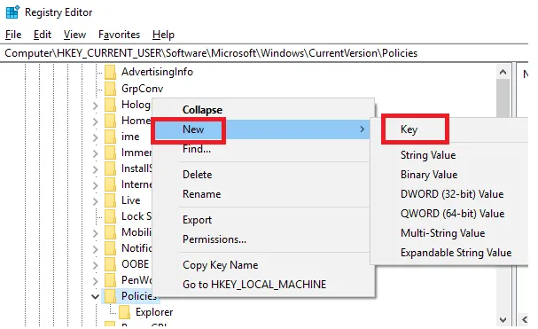

Don’t see the Explorer folder in Policies? You can**right click it**and click **New**, then click**Key.**Once the new folder has been created, rename it to **Explorer**, thenclick away from the folder to finalize the name.

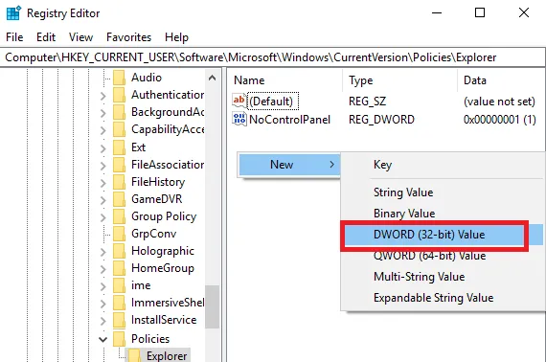

Next, click on the **Explorer**folder. After, right click an empty space on the right side of the registry editor.Then, click**New**, thenclick **DWORD (32-bit) Value**.

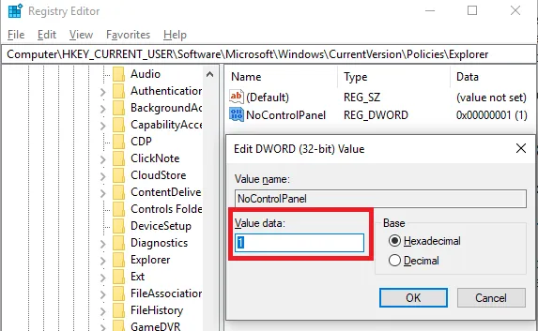

Where it says ‘New Value #1’, type **NoControlPanel** then press enter.After that,double click **NoControlPanel** and **change the value data from 0 to 1**. Click OK.

That’s it! **Now, restart your PC** and test to see if the settings menu and control panel are blocked. If they are, you can revert the account back to a standard account so that the setting cannot be removed.